**Practical No. 03**

**Aim:** Program to generate logs

**Basic Git init**

Git init command creates a new Git repository. It can be used to convert an existing, undersigned project to a Git repository or initialize a new, empty repository. Most other Git commands are not available outside of an initialize repository, so this is usually the first command you’ll run in a new project.



**Basic Git status**

The git status command displays the state of the working directory and the staging area. It lets you see which changes have been staged, which haven't, and which files aren't being tracked by Git. Status output does not show you any information regarding the committed project history.

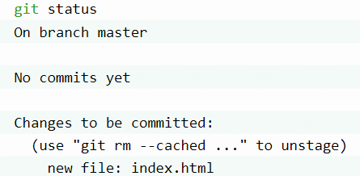

**Basic Git add command**

The git add command adds a change in the working directory to the staging area. It tells Git that you want to include updates to a particular file in the next commit. However, git add doesn't really affect the repository in any significant way—changes are not actually recorded until you run git commit





**Basic Git commit**

The git commit command captures a snapshot of the project's currently staged changes. Committed snapshots can be thought of as “safe” versions of a project—Git will never change them unless you explicitly ask it to. Prior to the execution of git commit, The git add command is used to promote or 'stage' changes to the project that will be stored in a commit. These two commands git commit and git add are two of the most frequently used.

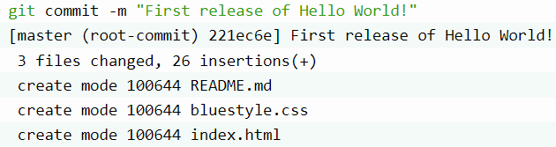

**Basic Git log**

Git log command is one of the most usual commands of git. It is the most useful command for Git. Every time you need to check the history, you have to use the git log command. The basic git log command will display the most recent commits and the status of the head. It will use as:

